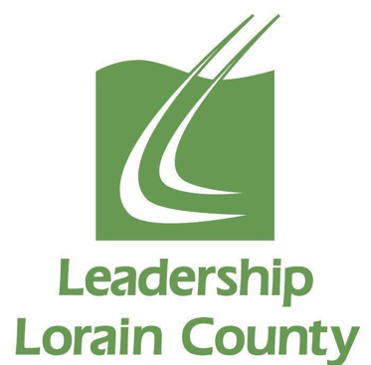

Job Title: President and Chief Executive Officer (CEO)
Classification: Exempt

Role as President and CEO
The President and Chief Executive Officer (CEO) serves as the chief administrator and reports to the Board of Directors; demonstrates the ability to develop and articulate the vision of the Leadership Lorain County; provides leadership to the organization, administering its operations; assists in the development of objectives; acts as principal spokesperson, in collaboration with the Board Chair; initiates and maintains positive relationships with staff, board, nonprofit, government, corporate and community leaders; keeps up-to-date on issues facing leadership and community needs; establishes agenda items and outlines each into action items for completion by committees and subcommittees; forms a disciplined approach to achieving goals and objectives of the organization.

The President and CEO must be proficient in and have an above average ability in the areas of planning, monitoring, fundraising, fiscal administration, proposal writing, organizational skills, written and oral communication, planning and evaluation, human resource administration, community and public relations, vision, and strategic planning.

Primary Responsibilities
- Board Administration and Support – Supports operations and administration of Board by advising and informing Board members, interfacing between Board and staff, and supporting Board’s evaluation of CEO, Executive Committee Members and Committee Chairs
- Program, Product and Service Delivery -- Oversees design, marketing, promotion, delivery and quality of programs, materials, and services
- Financial, Risk, and Facilities Management – Recommends yearly budget for Board approval and prudently manages organization’s resources within those budget guidelines according to current laws and regulations in collaboration with Treasurer and Accountant
- Human Resources Management – Effectively manages the human resources of LLC according to authorized personnel policies and procedures that fully conform to current laws and regulations
- Community and Public Relations – Assures LLC and its mission, programs, materials and services are consistently presented in strong, positive image to relevant stakeholders
- Fundraising – Oversees fundraising planning and implementation, including identifying resource requirements, researching funding sources, establishing strategies to approach funders, submitting proposals, and administering fundraising records and documentation
- Signature Program – Supports the Director of Community Outreach and Development design, develop and deliver programming for the Signature Program
- Community Representative – Participate in community outreach opportunities including board service
- Performs other duties as necessary or assigned

Position Requirements
- Significant and proven leadership skills developed through several years in senior management positions. Excellent organizational development, interpersonal, marketing, communication, administration and personnel management skills essential
- Is visionary, trustworthy, diplomatic, understanding and innovative with high energy level
- Experience managing budgets
- Success at fund development, including knowledge of and success in attracting foundation and corporate grants; ability to identify, steward and solicit individual donors
- Excellent communication skills, both written and oral; strong presentation skills
- The ability to foster a healthy organizational culture, to encourage teamwork and collaboration; strong interpersonal skills that include the ability to inspire and motivate; effective at conflict management
- Ability to raise the visibility of the organization through successful marketing including expansion of the membership and alumni base
- Excellent analytical skills
- Experience working with and developing an effective Board of Directors
- Must be highly motivated and possess a personal commitment to the success of LLC
- Must be detail oriented and have the ability to prioritize
- Ability to be a team player in a fast-paced environment

Working Conditions and Physical Demands
- Employee may be required to remain stationary for extended periods of time.
- Employee will be required to navigate through office and/or manufacturing locations.
- Employee will frequently be required to actively listen and exchange information.
- Employee will be required to observe and assess information received via computer.
- Requires use of computer and telephone.
- Some lifting of supplies and equipment up to 50 pounds

Leadership Lorain County provides equal employment opportunity to all applicants and employees. No person is to be discriminated against in any aspect of the employment relationship due to race, religion, color, sex, age, national origin, disability, citizenship status, marital status, veteran status or any other reason prohibited by law.

All employment offers are contingent upon successful completion of our pre-employment drug screening and background/criminal check, consistent with applicable laws.

